Cloud Project - Gas as a Service (GaaS)

170000366, 240005195, 240005134
Lois Dara D. Sanglap, Dustin Dwayne N. Diaz, and Justin D. Grumal
562.619 Cloud Application Development
Dr. Ahmad Wedyan
11 November 2026

Table of Contents
1.0 Introduction 3
2.0 System Overview 3
2.2 SaaS Solution 3
2.3 Implemented Features 3
3.0 Service-Oriented Architecture 4
3.1 GaaS SOA Diagram 5
3.1.1 Price Service 6
3.1.2 Station Service 6
3.1.3 Geo Location Service 7
3.2 Services Communication Flow 7
3.2.1 Geo Location Service to Station Service 7
3.2.2 Station Service to Price Service 8
3.2.3 Price Service and Final Output 8
3.3 SOA Application 8
3.4 API Design 9
4.0 Model-View-Controller Architecture 11
4.1 GaaS MVC Website Diagram 12
4.1.1 User to MVC Website 12
4.1.2 GeoLocation API to MVC Website 12
4.1.3 Azure Function API to Core Web API 13
4.1.4 External API to MVC Website 13
4.2 Technology Stack 13
5.0 Deployment 14
5.1 Deployment Instructions 14
5.2 Website output 16
6.0 Security Notes 19
6.1 Role-Based Access Control (RBAC) 19
6.1.1 Admin Role 19
6.1.2 User Role 20
6.2 API Endpoints Security 20
7.0 Testing Logs 21
8.0 Team Contribution Report 50
8.1 Group Diary 50
8.2 Lois Dara Sanglap Diary 51
8.3 Justin Grumal Diary 53
8.4 Dustin Dwayne Diaz Diary 55
9.0 Bibliography 57

Azure link for GaaS Website:
https://gaasstation-aqa4fraqe8fwftg0.eastasia-01.azurewebsites.net/
Azure link for GaaS Api (Azure Function):
gaasapi-dyd4aec8ecczcaae.newzealandnorth-01.azurewebsites.net
Azure link for GeoLocation (Core Web Api)
geolocatoin-eyf7bqfefgfff8a2.eastasia-01.azurewebsites.net

1.0 Introduction
This document presents the formal Architectural Design, and Operational Report for the GaaS platform. It outlines the system’s Service-Oriented Architecture along with the details of core services, recording API design, and provides deployment instruction for Microsoft Azure. Moreover, this report explains the security control, Role-Based Access Control (RBAC) implementation, and test logs governing the GaaS platform.

2.0 System Overview
2.1 Business Problem
Fluctuating fuel prices continue to place pressure on New Zealanders' cost of living (Edmunds, 2026). In Auckland, prices for petrol and diesel can vary depending on brands and suburbs, and motorists often lack a quick, reliable way to compare them. The current existing sources of price information are manually inputted or crowdsourced, which can leave data outdated or inconsistent, and drivers spend additional time and money searching for the best option.

2.2 SaaS Solution
GaaS provides a cloud-hosted Software as a Service solution that automates fuel price matching across the Auckland region. By centralising real-time pricing data and geospatial filtering, GaaS eliminates the friction of price comparison, making everyday commuters make cost-effective decisions at the pump effortlessly.

2.3 Implemented Features
Features ID | Features | Description
F01 | User Identity & RBAC | Manages secure authentication and role-based access control to enforce appropriate system permissions for administrators and standard users
F02 | Price & Station Search | Enables querying and filtering at Price and Station data by specific branches or fuel types and filter parameters like quantity
F03 | Price & Station CRUD | Provides management capabilities such as Create, Update, and Delete gas stations and fuel pricing records which only an admin can access
F04 | GeoLocation Service | Uses latitude and longitude coordinates to pinpoint current location which then finds all gas stations within a specified kilometre radius
F05 | API Key Generation | Generates a secure API keys to authenticate requests and allow application integration
Fig 1. GaaS features table

3.0 Service-Oriented Architecture
Understanding Service-Oriented Architecture (SOA), it is essential to understand what a ‘Service’ is. A service is a unit of software that performs a specific task, built with three components (Mulesoft, n.d.):
- Interface - Service provider that performs requests to service consumers.
- Contract - How service providers and consumers interact together.
- Implementation - The backend code or logic that executes the tasks.
Anandamurugan and Priyaa (2015) stated that SOA is an architectural framework that enables consumer and service providers to interact through services. The image below (Section 3.1.1) is the SOA diagram for GaaS that illustrates how the user interacts with decoupled services and a database:

3.1 GaaS SOA Diagram
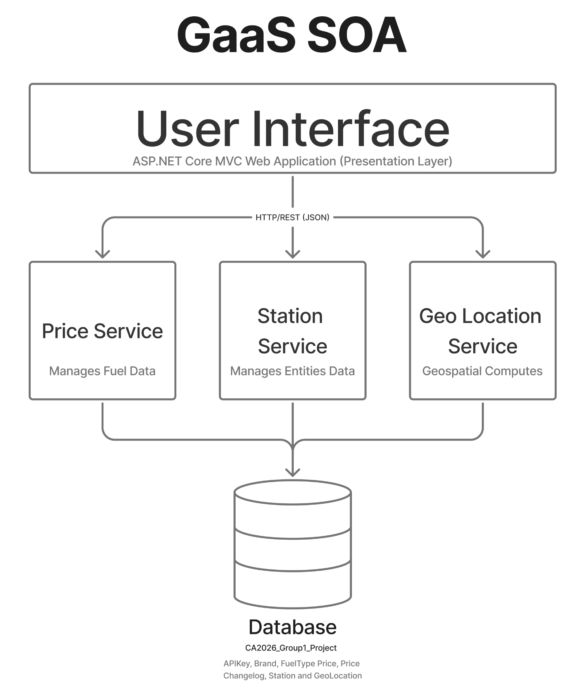
Fig 2. GaaS SOA diagram
Key Components:
- User: Service consumer or client initiating requests
- Services:
  - Price Service
  - Station Service
  - Geo Location Service
- Database: Centralised storage layer accessed directly and indirectly by services.

3.1.1 Price Service
Manages all fuel price records across fuel stations and fuel types (91, 95, 98 and Diesel). This service acts as the core administrative price management layer, providing admins to cooperate Create, Read, Update and Delete (CRUD) on the price service metadata.
Data Type | Input | Data Type | Data Used
int | stationID | int | PriceID
int | | string | fueltype | int | Station
int | | string | quantity | int | FuelType
string | apiKey | decimal | PriceValue
 |  | FK Station | FuelTypeNavigation
 |  | FK FuelType | StationNavigation
Fig 3. Price Service data input and used table

3.1.2 Station Service
Manages the main records for fuel stations across the Auckland region, maintaining entity data, branch details, and location coordinates. This service provides the core data layer for administrative management, allowing Admins to operate CRUD on the station service metadata.
Data Type | Input | Data Type | Data Used
int | string | brand | int | StationID
string | branch | int | GeoLocation
string | address | int | Brand
string | apiKey | string | Branch
 |  | FK Brand | BrandNavigation
 |  | FK GeoLocation | GeoLocationNavigation
Fig 4. Station Service data input and used table

3.1.3 Geo Location Service
Calculates the distance between two points in spherical boundaries between the user’s current location and fuel stations across Auckland using the ‘Haversine’ formula (Veness, n.d.). This service filters and outputs a sorted list of all stations operating within the search radius. This is directly displayed into the main GaaS web page, rendering matching station pins on the map view and the sidebar list with a real-time fuel prices and stations.
Data Type | Input | Data Type | Data Used
decimal | longitude | int | GeoLocationID
decimal | latitude | int | Brand
int | radiusKm | string | Branch
string | apiKey | string | AddressString
 |  | decimal | Latitude
 |  | decimal | Longitude
Fig 5. Geo Location Service data input and used table

3.2 Services Communication Flow

3.2.1 Geo Location Service to Station Service
Event Trigger: The API receives client coordinates (`latitude`, `longitude` & `radiusKM`).

Data Transfer / Data Exchange: Geo Location Service calculates the coordinated locations to identify all `GeoLocationID` records that fall within the radius and passes these ID’s along with the computed distance over to the Station Service.

3.2.2 Station Service to Price Service
Event Trigger: Receiving valid ID from the Geo LocationService

Data Transfer / Data Exchange: Station Service takes the `GeoLocationID` list and queries its entity records. Using the `BrandNavigation` relationship, resolving the station attributes (`StationID`, `Brand`, `Branch`, and `AddressString`). Station Service then forwards the matched `StationID` list to the Price Service.

3.2.3 Price Service and Final Output
Event Trigger: Receiving chosen `StationID` keys from the Station Service.

Data Transfer / Data Exchange: Price Service filters active price entries matching those `StationID` keys through `StationNavigation. Price Service maps the corresponding `FuelType` through FuelTypeNavigation to select the `PriceValue`.

3.3 SOA Application
GaaS demonstrates Service-Oriented Architecture (SOA) principles through the following core technical implementations:
- Decoupled Service Layers - The presentation layer is kept separate from backend processing. The MVC website focuses on rendering the User Interface (Views) and routing requests (Controller), delegating spatial calculation, pricing queries, and mapping tasks to independent backend services.
- Autonomous Serverless Services - Main features are divided into specialised, self-contained units. The GeoLocation API handles radius calculation and map price, while GaaS API runs independent modules.
- API Security & Key Governance - Service security is governed by dedicated keys. Search queries accept read only or admin keys, unlike administrative CRUD operations that require an admin API key to modify data in the backend database.
- Standardized Communication Contracts - The MVC website, GeoLocation API, Gaas API, and third-party API communicates using standard HTTP request/response format carrying structured JSON data.

3.4 API Design
HTTP Verb | Endpoint Path | Query Parameter | Access Level | Response
GET | api/location/query | ?{longitude=}&{latitude=}&{radiusKm=}&{apiKey=} | Public | ‘200 OK’: List of stations within the radius are displayed on the map or 400 Bad Request
POST | api/location/query | {  “longitude” : ,  “latitude”: ,  “radiusKm”: ,  “apiKey”:  } | Public | ‘200 OK’: List of stations within the radius are displayed on the map or 400 Bad Request
GET | GaaS/price/search | ?{station=?}&{fueltype=?}&{min=}&{max=?}&{quantity=?}&{key=} | Public | ‘200 OK’: List of station according to the user query or 400 Bad Request
POST | GaaS/price/search | {  “station” ?: ,  “fueltype”: ?,  “min”: ?,  “max”:?,  “quantity”:?,  “key”:  } | Public | ‘200 OK’: List of station according to the user query or 400 Bad Request
GET | GaaS/price/create | ?{station=}&{fueltype=}&{priceValue=}&{key=} | Admin | ‘201 CREATED’: Gas price is created or 400 Bad Request
POST | GaaS/price/create | {  “station” : ,  “fueltype”: ,  “priceValue”:,  “key”:  } | Admin | ‘201 CREATED’’: Gas price is created or 400 Bad Request
GET | GaaS/price/update | ?{priceID=}&{station=}&{fueltype=}&{priceValue=}&{key=} | Admin | 200 OK’: Gas price is updated or 400 Bad Request
POST | GaaS/price/update | {  “priceID”: ,  “station” : ,  “fueltype”: ,  “priceValue”:,  “key”:  } | Admin | 200 OK’: Gas price is updated or 400 Bad Request
GET | GaaS/price/delete | ?{priceID=}&{key=} | Admin | 200 OK’: Gas price is deleted or 400 Bad Request
POST | GaaS/price/delete | {  “priceID”:,  “key”  } | Admin | 200 OK’: Gas price is deleted or 400 Bad Request
GET | GaaS/station/search | ?{brand=?}&{branch=?}&{address=?}&{quantity=?}&{key=} | Public | 200 OK’: Gas price is displayed or 400 Bad Request
POST | GaaS/station/search | {  “brand”: ?,  “branch”: ?,  “address”: ?,  “quantity”: ?,  “key”:  } | Public | 200 OK’: Gas price is displayed or 400 Bad Request
GET | GaaS/station/create | ?{address=}&{latitude=}&{longitude=}&{brand=}&{branch=}&{key} | Admin | ‘201 CREATED’’: Gas station is created or 400 Bad Request
POST | GaaS/station/create | {  “address”: ,  “latitude”: ,  “longitude”: ,  “brand”: ,  “branch”:  } | Admin | ‘201 CREATED’’: Gas station is created or 400 Bad Request
GET | GaaS/station/update | ?{stationID=}&{address=}&{latitude=}&{longitude=}&{brand=}&{branch=}&{key=?} | Admin | ‘200 OK’: Gas station is updated or 400 Bad Request
POST | GaaS/station/update | {  “stationID” ,  “address”: ,  “latitude”: ,  “longitude”: ,  “brand”: ,  “branch”:  } | Admin | ‘200 OK’: Gas station is updated or 400 Bad Request
GET | GaaS/station/delete | ?{stationID=}&{key=} | Admin | ‘200 OK’: Gas station is deleted or 400 Bad Request
POST | GaaS/station/delete | {  “stationID”: ,  “key”:  } | Admin | ‘200 OK’: Gas station is deleted or 400 Bad Request
GET | GaaS/api/genkey | ?{keyName=?}&{permission=} | Public | ‘200 OK or 400 Bad Request
POST | GaaS/api/genkey | {  “keyName”: ?,  “permission”:  } | Public | ‘200 OK or 400 Bad Request
Fig 6. API Design table

4.0 Model-View-Controller Architecture
Model-View-Controller (MVC) is an architectural pattern separating an application into three main components (Anderson, n.d.):
- Model - implements the logic for the application’s data.
- View - display the application User Interface.
- Controller - handles the user interactions, working with the Model, and selects the view to render and displays it to the View.
GaaS web application implements this architectural pattern using the ASP.NET Core MVC framework. By enforcing separation of concerns, the presentation layer remains lightweight and maintainable, handling user display logic independently while delegating backend processing and spatial calculations to RESTful Web API and serverless Azure Functions. Refer to the system flow in Section 4.1 for the complete end to end data flow between the User, View, Controller, Model, Databases, and external APIs.

4.1 GaaS MVC Website Diagram
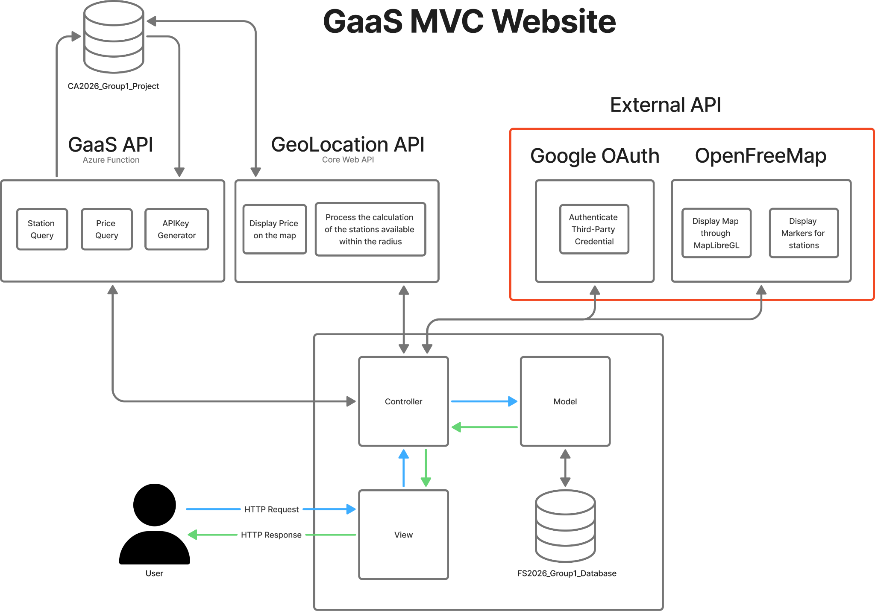
Fig 7. GaaS MVC Website diagram

4.1.1 User to MVC Website
The user interacts with the application through a responsive Web Graphical User Interface (GUI) by sending HTTP requests to the View. The View communicates with the Controller to process actions, update the Model which interfaces with the FS2026_Group1_Database, and return the final HTTP Response back to the user.

4.1.2 GeoLocation API to MVC Website
The GeoLocation Service acts as an ASP.NET Core Web API containing two main execution components:
- Process the calculations of the stations available within the radius.
- Display price on the map.
It exchanges data directly with the MVC Controller and queries the backend
CA2026_Group1_Database.

4.1.3 Azure Function API to Core Web API
The GaaS API is hosted as an Azure Function containing three core modules:
- Station Service
- Price Service
- KeyGen
It handles background data processing, handles query keys, interacts with the Database, and communicates directly with the MVC Controller.

4.1.4 External API to MVC Website
The MVC Controller communicates directly with two external services:
- Google OAuth - Invoked by the Controller to authenticate third-party credentials.
- OpenFreeMap - Invoked by the Controller to display a map through MapLibreGL and display markers for stations.

4.2 Technology Stack
Language | C#
Web App | ASP.NET Core MVC
Frontend | HTML, CSS, Bootstrap, JavaScript
API | ASP.NET Core Web API and MapLibreGL & Google OAuth API
Serverless Task | Azure Function
Data Access | Entity Framework Core
Database | SQL Server
Authentication | ASP.NET Core Identity and Google authentication
Hosting | Azure App Service
Source Control | GitHub
Fig 8. Technology stack table

5.0 Deployment

5.1 Deployment Instructions
Step by Step instruction for deployment in Azure:
- Right-click on the project and select “Publish”
- Pick “Azure” and click “Next”
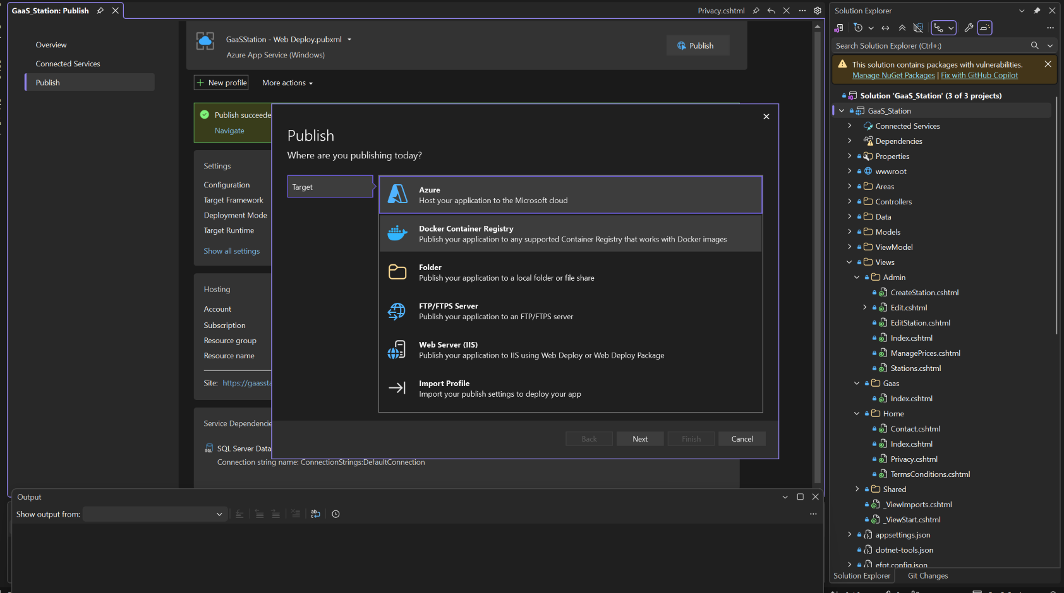
- Select “Azure App Service (Windows)” and click “Next”
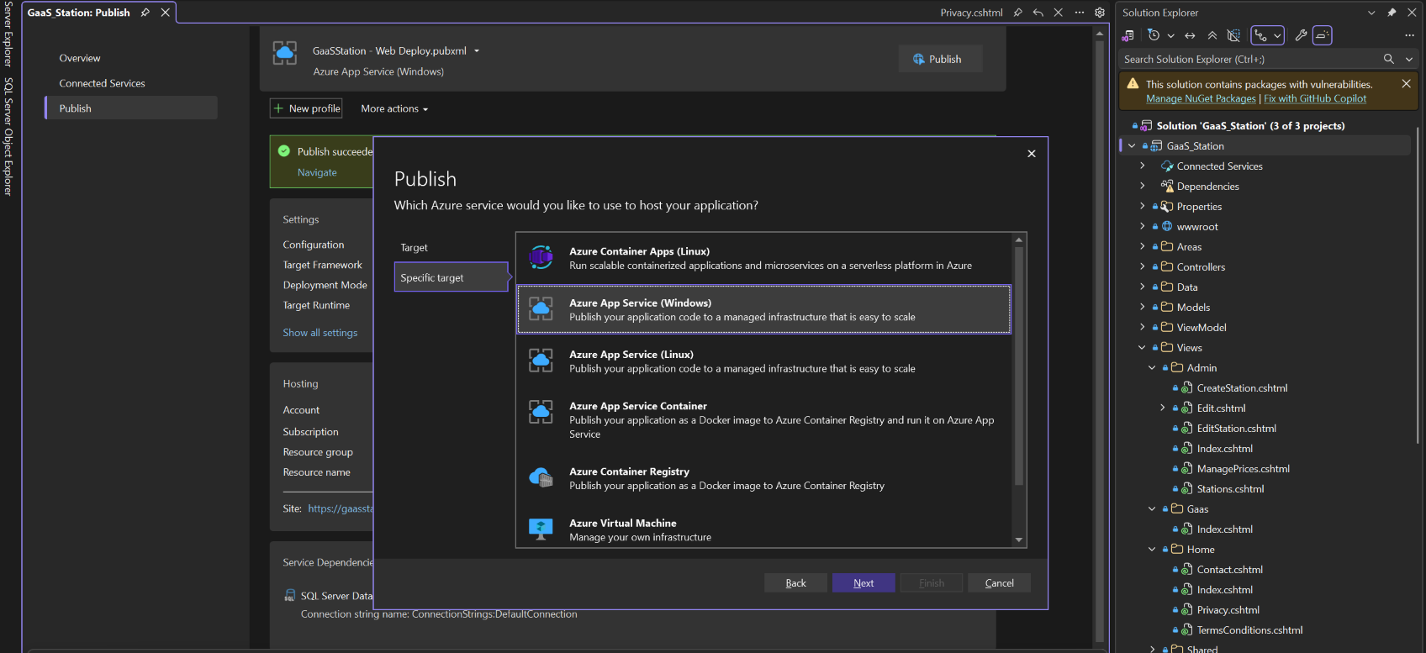
- Login to your Azure account
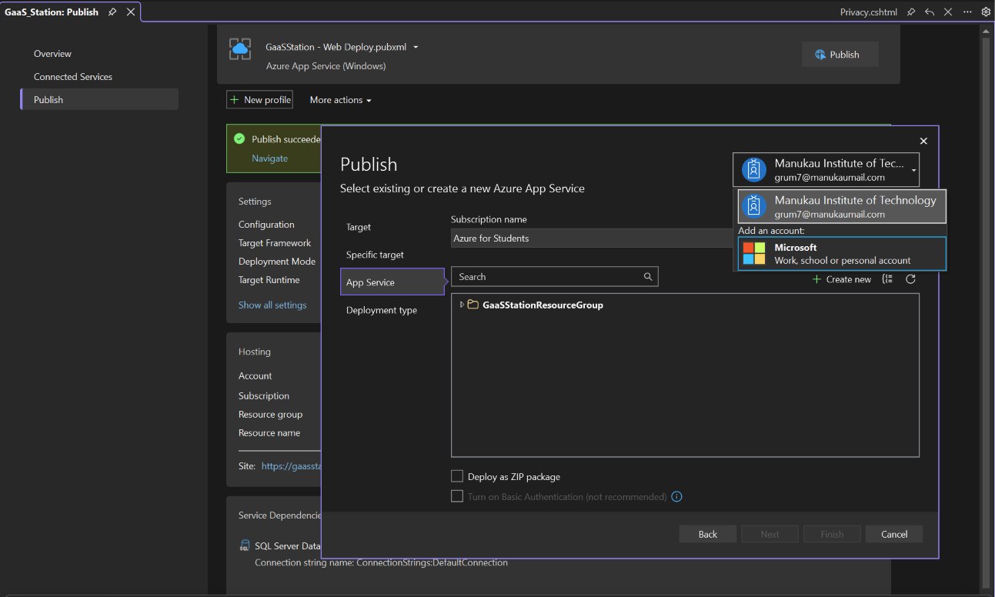
- Click on “Create New” and configure hosting plan to the following:
  - Location = East Asia
  - Size = Free
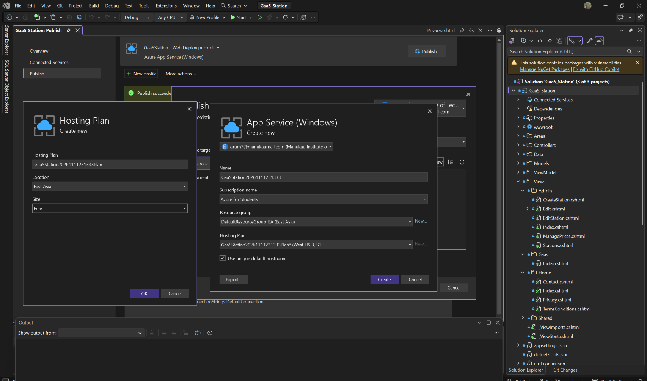
- Click “Create”
- Click “Finish”
- Click “Publish”
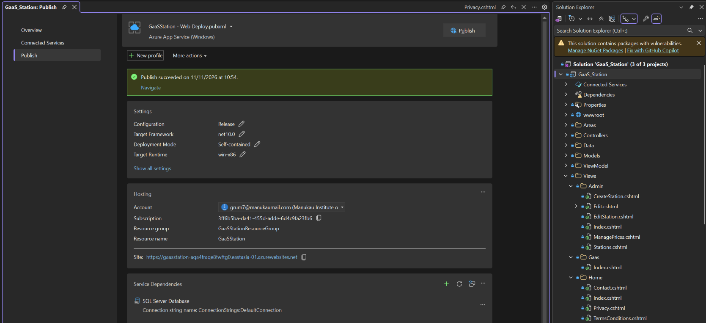
NOTE: Configure deployment mode to self-contained and target runtime to win x86 since “Platform” is configured to 32 bit by default. This setup is required to run the core web api.
Follow the above steps for publishing Azure functions and Core Web API since they are similar.
- Once published, in Microsoft Azure, navigate to the MVC’s environment variables and add variables found within the appsettings.json, such as Base URL or connection string for Azure function and core web api.
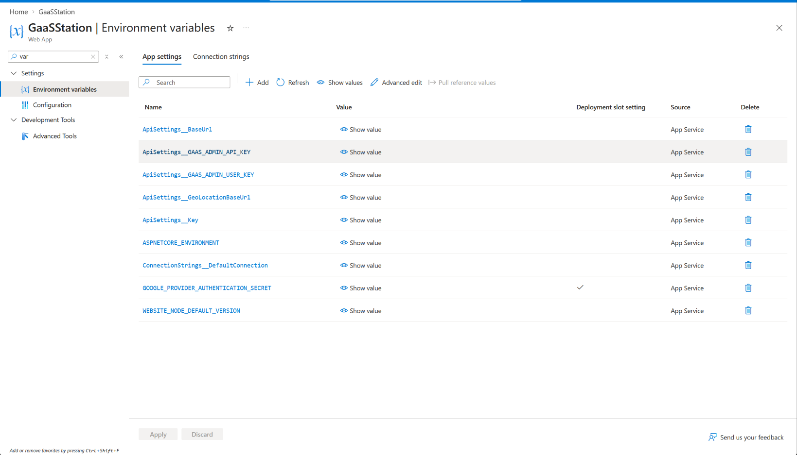
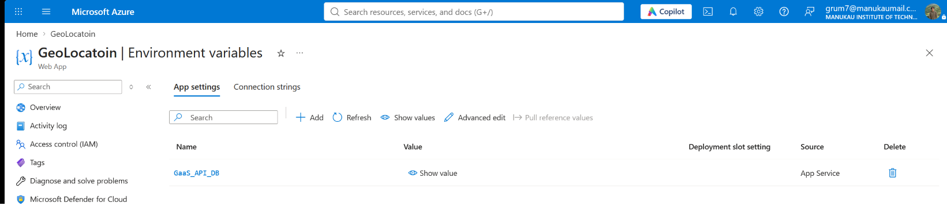
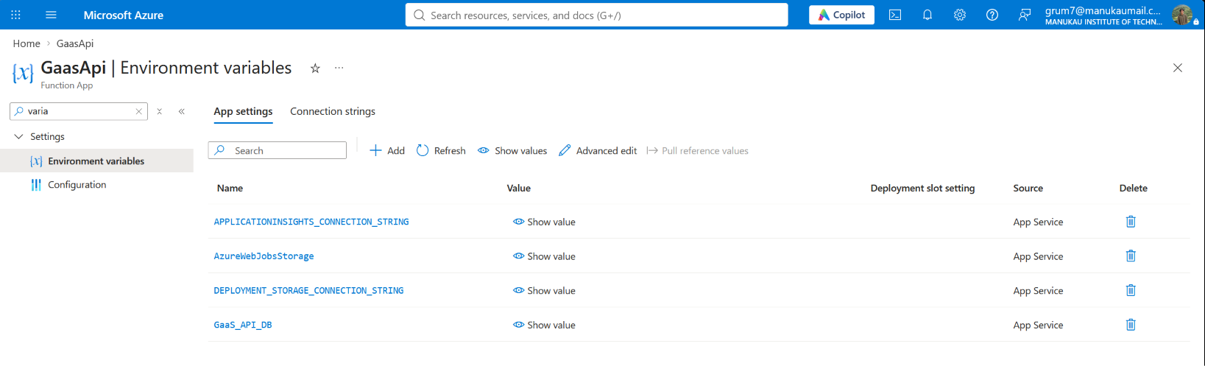

5.2 Website output

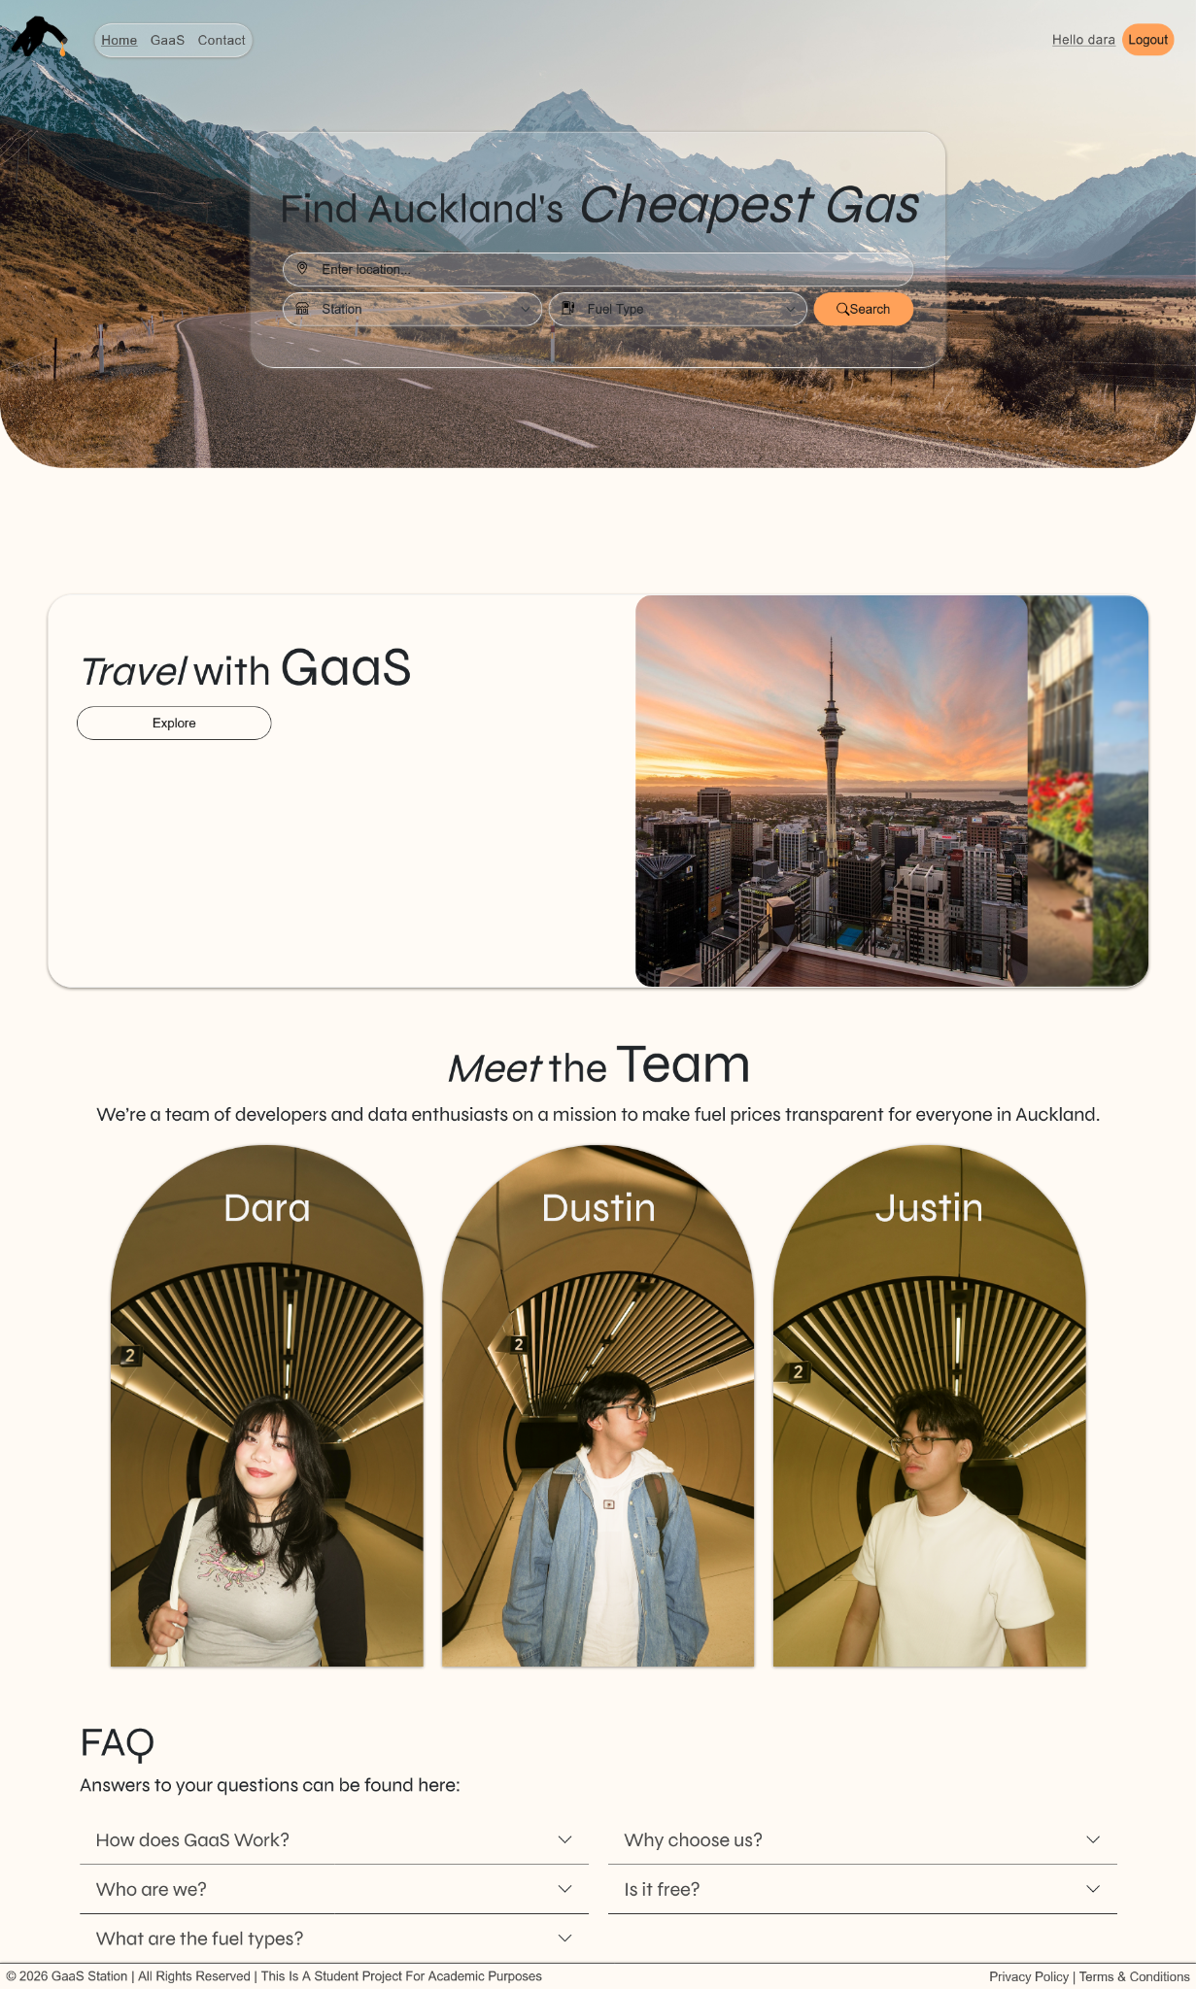
Fig 9. GaaS main homepage

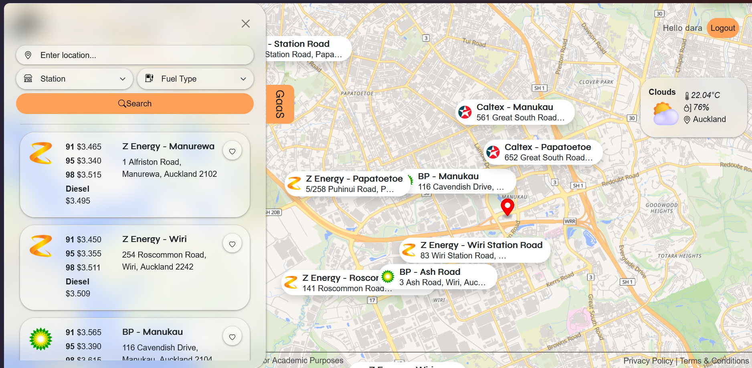
Fig 10. GaaS service page
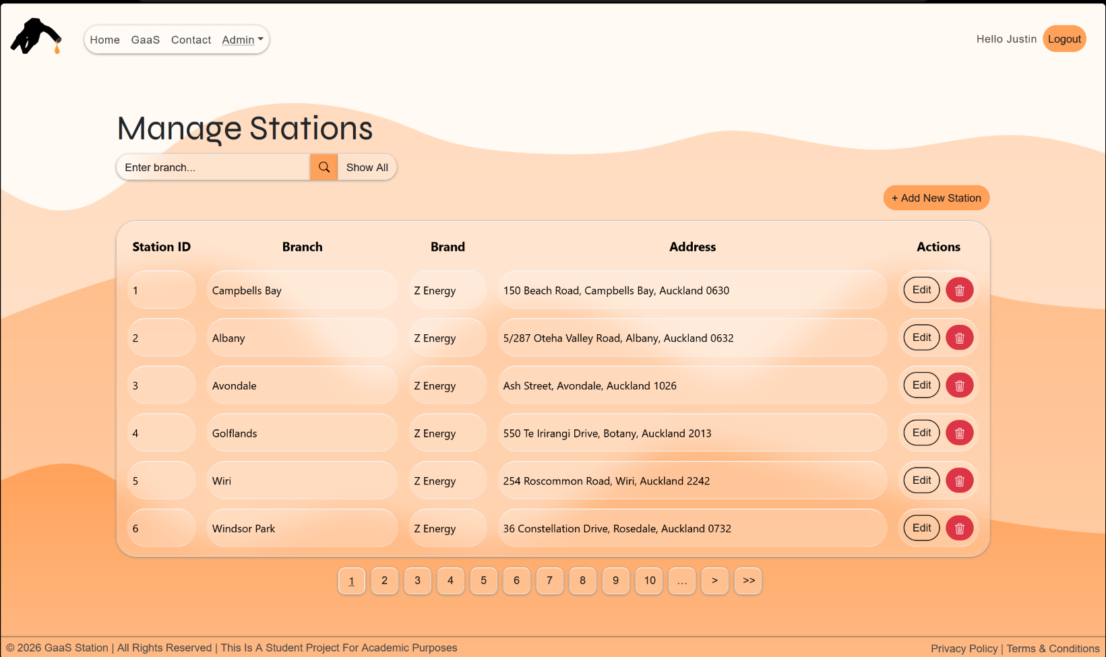
Fig 11. Manage station page (admin)

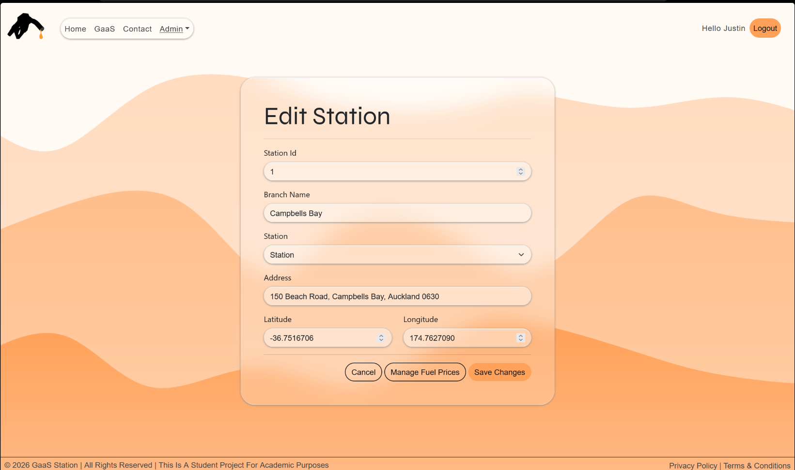
Fig 12. Edit Station page (admin)
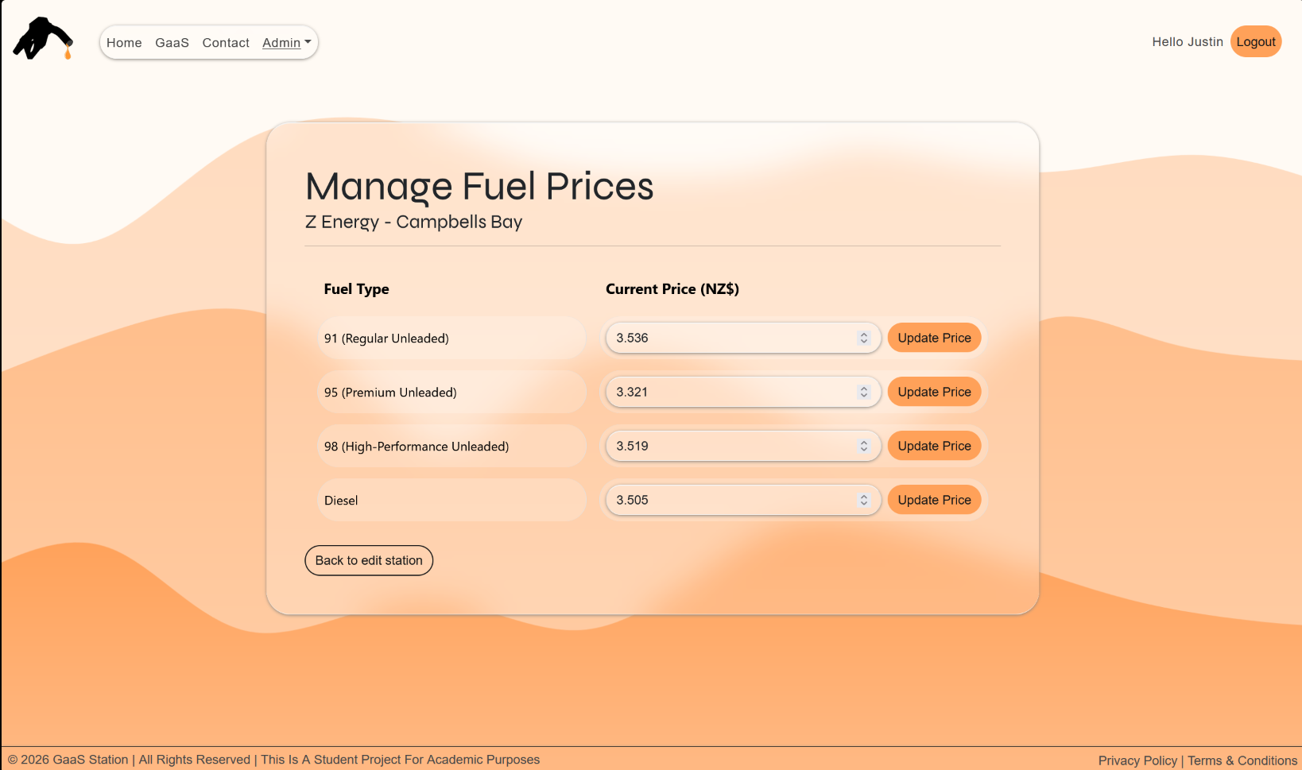
Fig 13. Manage fuel prices page (admin)
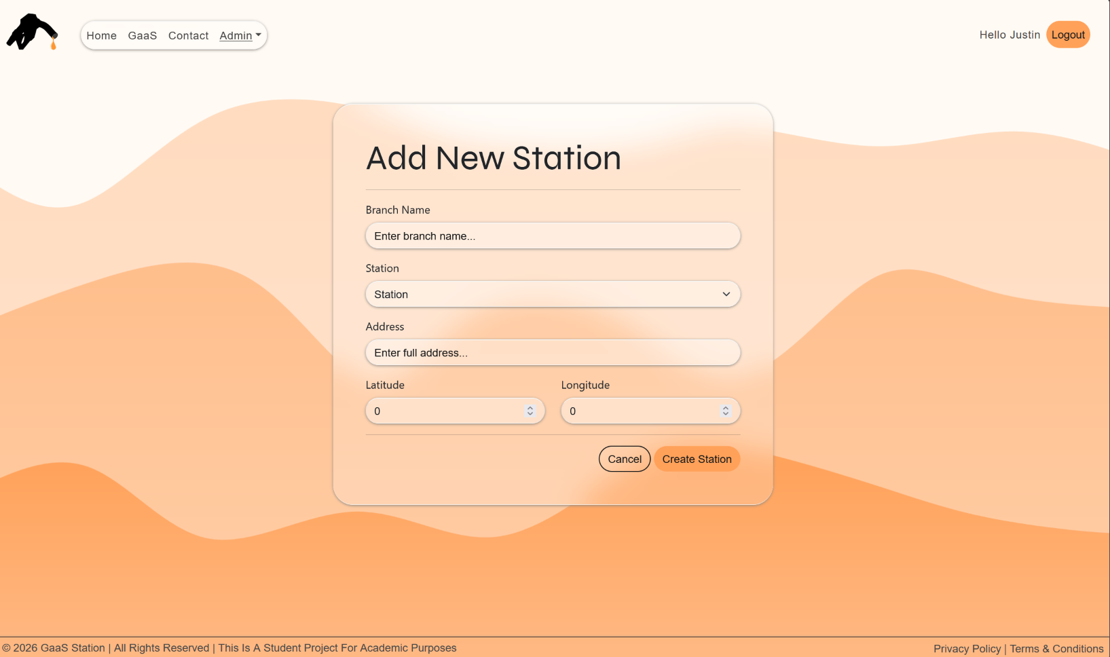
Fig 14. Add new station page (admin)

6.0 Security Notes
The security of GaaS is implemented through enforced data protection and access control through password hashing, token-based RBAC, and view level authorisation across API and presentation layers.

6.1 Role-Based Access Control (RBAC)
Role-Based Access Control (RBAC) is a security model that authorises end-user access to systems, applications, and data based on the user’s predefined role (Lindemulder & Kosinski, n.d.). GaaS has two specified roles in the system, admin and user; each role has different permissions and privileges granted according to their responsibilities. Sections 5.1.1 and 5.1.2 further explain admin and users, along with the provided samples for testing.

6.1.1 Admin Role
The admin role has privileges to add, remove, or update any records of price data and station lists which the website uses.

Email: justindegrumal@email.com
Password: Qwerty123$

6.1.2 User Role
The User Role is meant for normal user access, giving them the ability to view fuel price information and also find the closest stations according to their geographical location. Also, users have the ability to save their favourite stations.

Email: gustin@email.com
Password: Qwerty123$

6.2 API Endpoints Security
For the GaaS API, the endpoints are secured by having an API key parameter with hash key value and role permission to check what the key’s authorized access is. OAuth is implemented with the MVC to securely login but is not part of the API’s endpoints. The value of the api key is hashed with SHA256.

7.0 Testing Logs
Test ID | Description | Expected Result | Actual Result | Pass/Fail | Notes
TC01 | GET all stations from dbo.Station in the database, “CA2026_Group1_Project”.  URL: https://gaasapi-dyd4aec8ecczcaae.newzealandnorth-01.azurewebsites.net/GaaS/station/search?apikey=ga_xFxAMgwXYH2Wkd-DVhXLrSnHYEhGcRPb-1-as0x&code=p2WU9ZzI2eJ8EvU9CN_WnmzXNL--0vtILxnWDv_2bLGTAzFu855Dbg== | A JSON file containing a collection of station records with the following parameters:  “stationId”  “addressString”  “latitude”  “longitude”  “brandName”  “branch” | 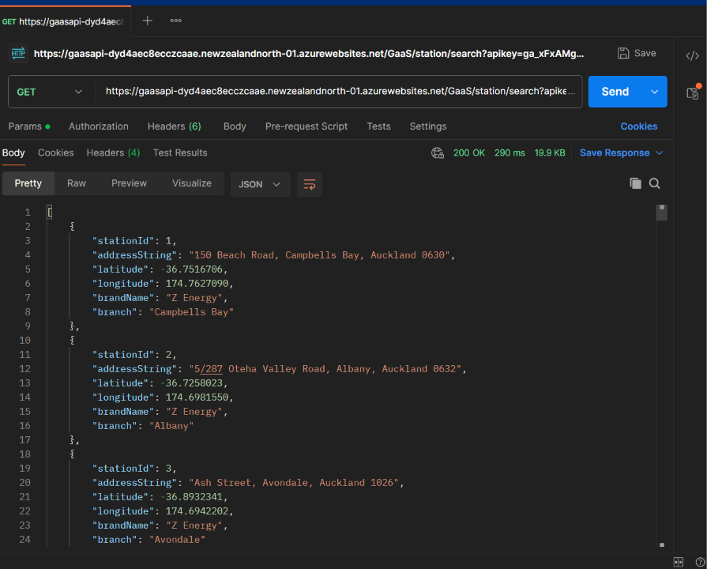 | Pass | All stations were received, including their:  “stationId”  “addressString”  “latitude”  “longitude”  “brandName”  “branch”
TC02 | GET | Search a specific station from dbo.Station in the database, “CA2026_Group1_Project”.  URL: https://gaasapi-dyd4aec8ecczcaae.newzealandnorth-01.azurewebsites.net/GaaS/station/search?address=150%20Beach%20Road,%20Campbells%20Bay,%20Auckland%200630&apikey=ga_xFxAMgwXYH2Wkd-DVhXLrSnHYEhGcRPb-1-as0x&code=p2WU9ZzI2eJ8EvU9CN_WnmzXNL--0vtILxnWDv_2bLGTAzFu855Dbg== | A JSON file containing a station with the address “150 Beach Road, Campbells Bay, Auckland 0630” with the following parameters:  “stationId”  “addressString”  “latitude”  “longitude”  “brandName”  “branch” | 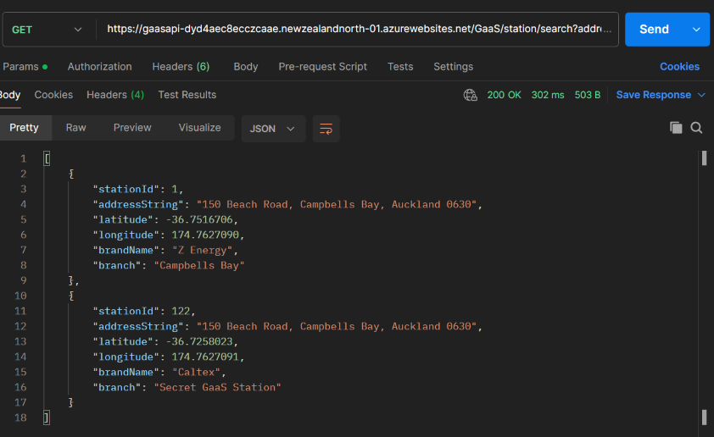 | Pass | The station with stationId:122 is a test station (not real); thus, two results appeared for searching stations with the address “150 Beach Road, Campbells Bay, Auckland 0630”
TC03 | POST | CREATE a new station and populate the database, “CA2026_Group1_Project”.  URL: https://gaasapi-dyd4aec8ecczcaae.newzealandnorth-01.azurewebsites.net/GaaS/station/create?code=p2WU9ZzI2eJ8EvU9CN_WnmzXNL--0vtILxnWDv_2bLGTAzFu855Dbg== | A station with the following properties is created:  {  “address”: “Test address”,  “latitude”: 12,  “longitude”: 3,  “brand”: 1,  “branch”: “Test branch”  } | 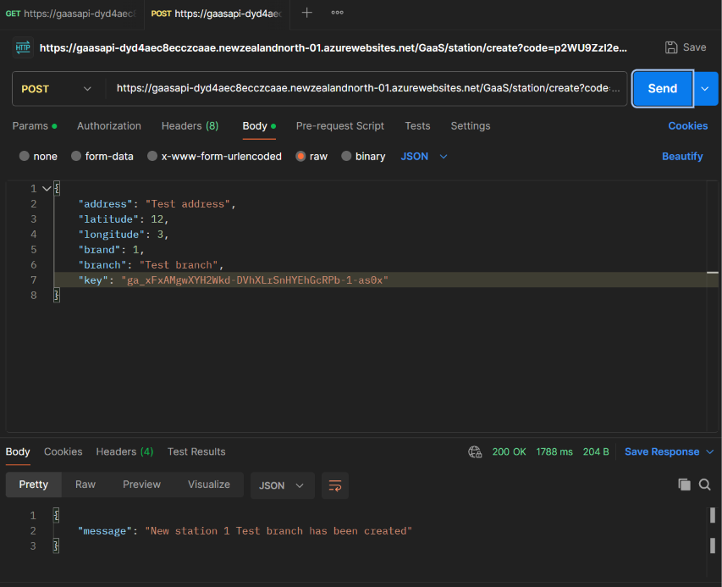 | Pass | “brand” is a foreign key to the table, dbo.Brand, where 1 represents “Z Energy”
TC04 | POST | UPDATE a station’s details.  URL: https://gaasapi-dyd4aec8ecczcaae.newzealandnorth-01.azurewebsites.net/GaaS/station/update?code=p2WU9ZzI2eJ8EvU9CN_WnmzXNL--0vtILxnWDv_2bLGTAzFu855Dbg== | Station with an id, 132, has their following properties updated to:  {  “address”: “Updated address”,  “latitude”: 32,  “longitude”: 22,  “brand”: 2,  “branch”: “Updated branch”  } | 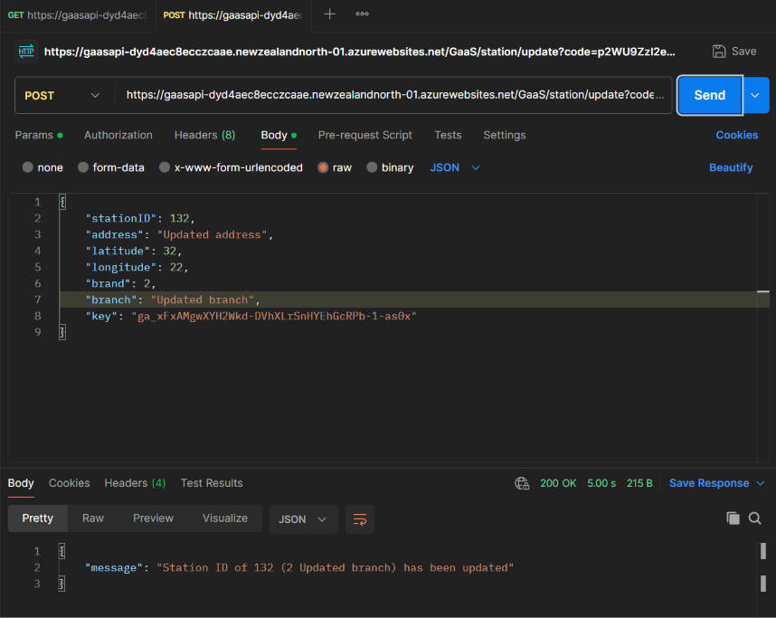  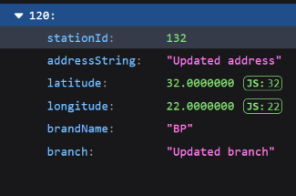 | Pass
TC05 | POST | DELETE a station with a specific Id.  URL: https://gaasapi-dyd4aec8ecczcaae.newzealandnorth-01.azurewebsites.net/GaaS/station/delete?code=p2WU9ZzI2eJ8EvU9CN_WnmzXNL--0vtILxnWDv_2bLGTAzFu855Dbg== | Station with an id, 132, is deleted from the table, dbo.station | 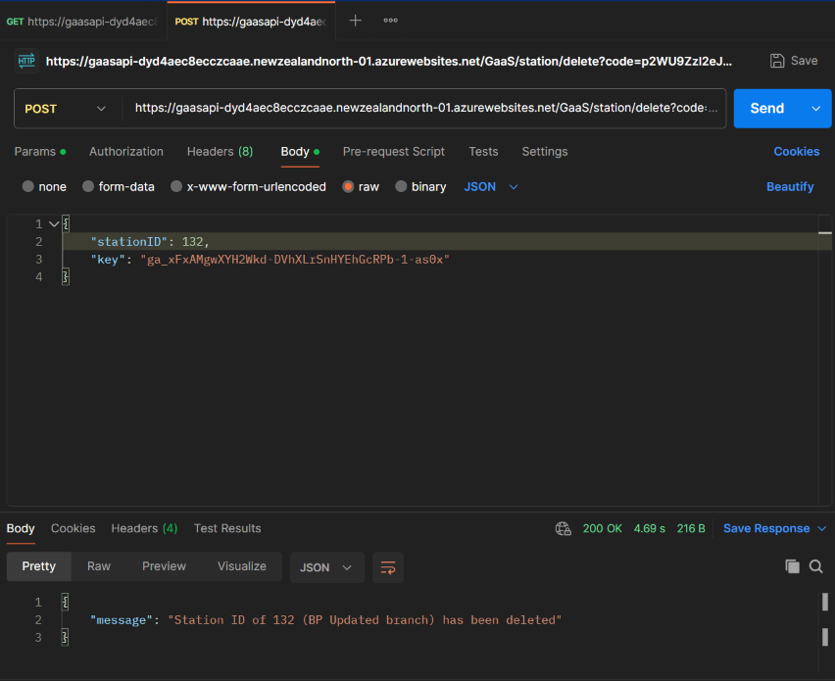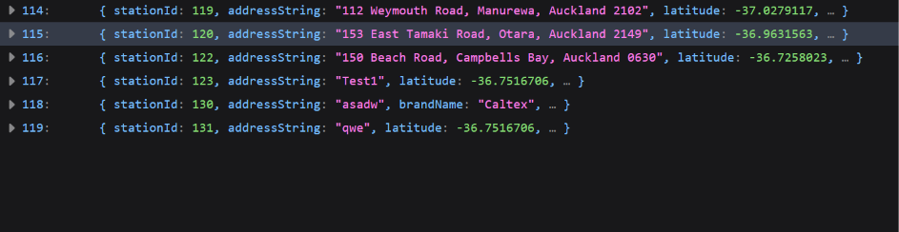 | Pass
TC06 | GET all prices for each fuel type from every station.  URL: https://gaasapi-dyd4aec8ecczcaae.newzealandnorth-01.azurewebsites.net/GaaS/price/search?station=&fueltype=&min=&max=&quantity=&key=ga_xFxAMgwXYH2Wkd-DVhXLrSnHYEhGcRPb-1-as0x&code=p2WU9ZzI2eJ8EvU9CN_WnmzXNL--0vtILxnWDv_2bLGTAzFu855Dbg== | A JSON file containing a collection of price records for every station with the following parameters:  “priceId”  “stationName”  “fuelType”  “priceValue” | 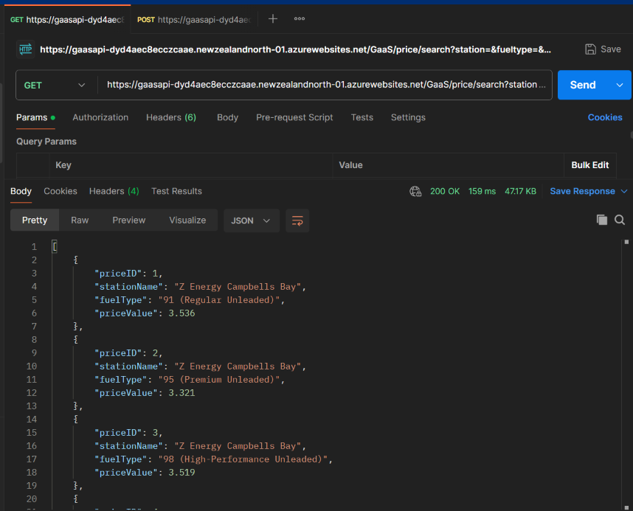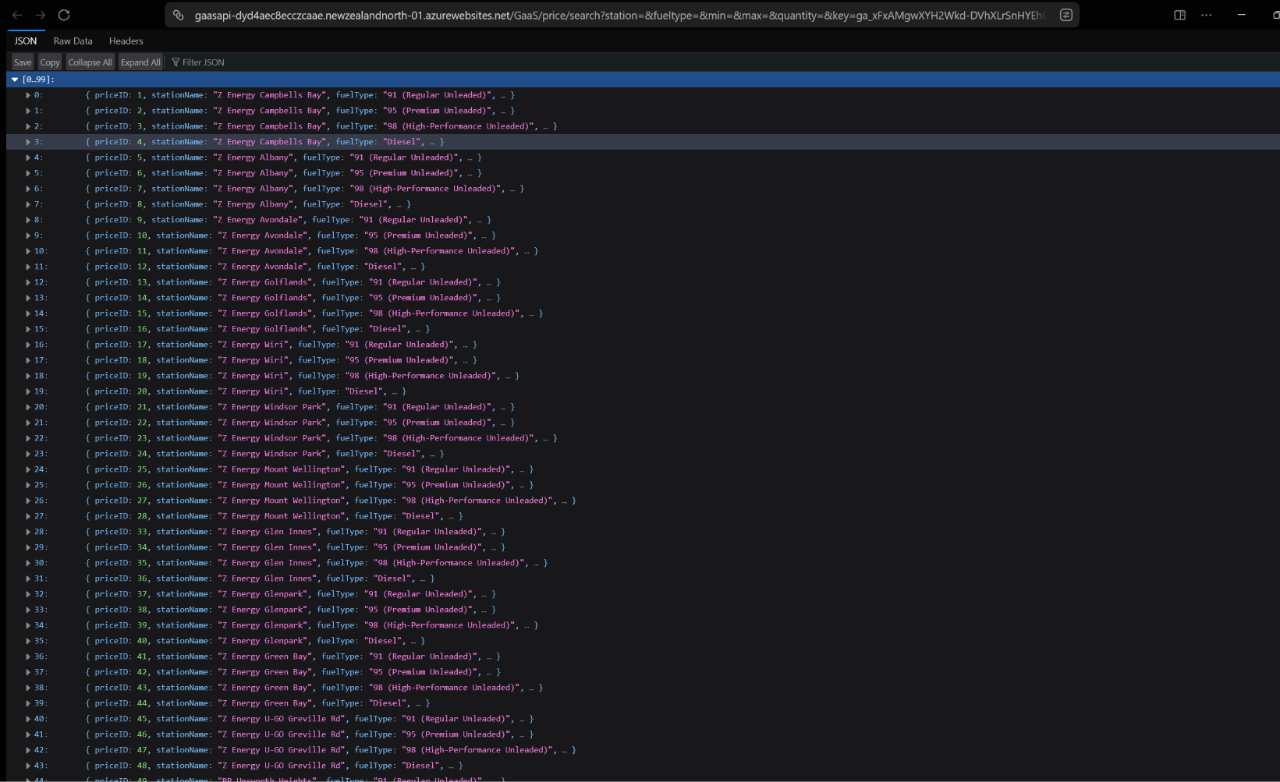 | Pass
TC07 | GET all prices for each fuel type from a specific station.  URL: https://gaasapi-dyd4aec8ecczcaae.newzealandnorth-01.azurewebsites.net/GaaS/price/search?station=84&fueltype=&min=&max=&quantity=&key=ga_xFxAMgwXYH2Wkd-DVhXLrSnHYEhGcRPb-1-as0x&code=p2WU9ZzI2eJ8EvU9CN_WnmzXNL--0vtILxnWDv_2bLGTAzFu855Dbg== | A JSON file containing a collection of price records for a station with an Id = 84. The JSON contains the following parameters:  “priceId”  “stationName”  “fuelType”  “priceValue” | 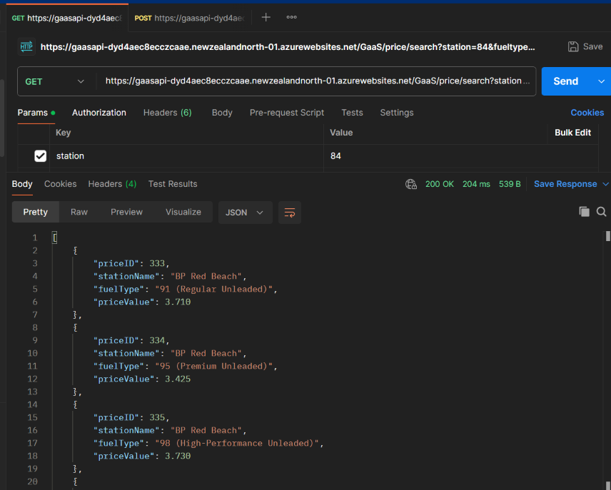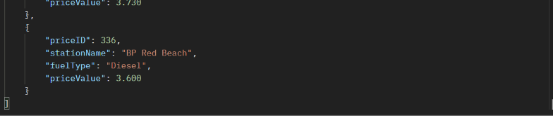 | Pass
TC08 | POST | Assign a fuel type and price to a specific station.  URL: https://gaasapi-dyd4aec8ecczcaae.newzealandnorth-01.azurewebsites.net/GaaS/price/create?code=p2WU9ZzI2eJ8EvU9CN_WnmzXNL--0vtILxnWDv_2bLGTAzFu855Dbg== | A price of NZ$3.12 has been assigned to a fuel type of “91 (Regular Unleaded)”. The station has an id of 133. | 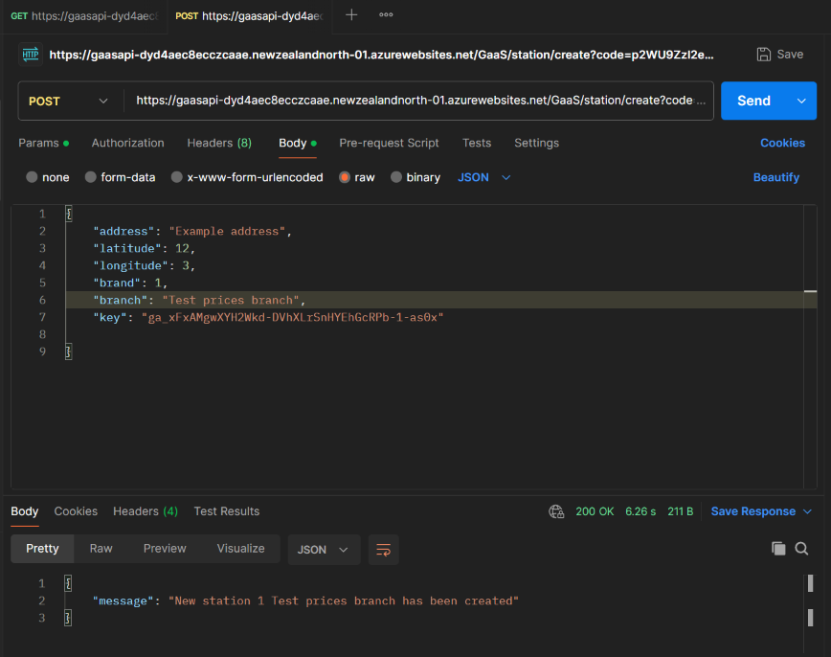  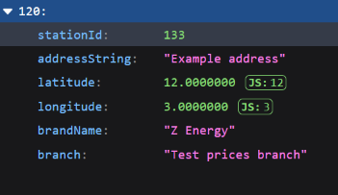  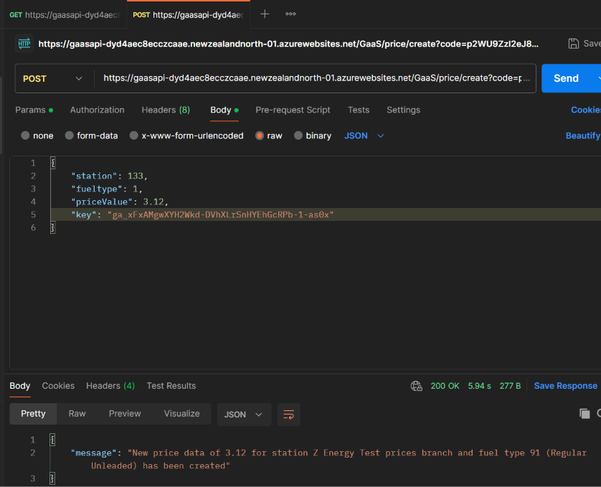  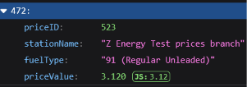 | Pass
TC09 | POST | UPDATE the price of an existing record.  URL: https://gaasapi-dyd4aec8ecczcaae.newzealandnorth-01.azurewebsites.net/GaaS/price/update?code=p2WU9ZzI2eJ8EvU9CN_WnmzXNL--0vtILxnWDv_2bLGTAzFu855Dbg== | The station with an Id of 133 had the price of “91 (Regular Unleaded)” updated to NZ$3.333. | 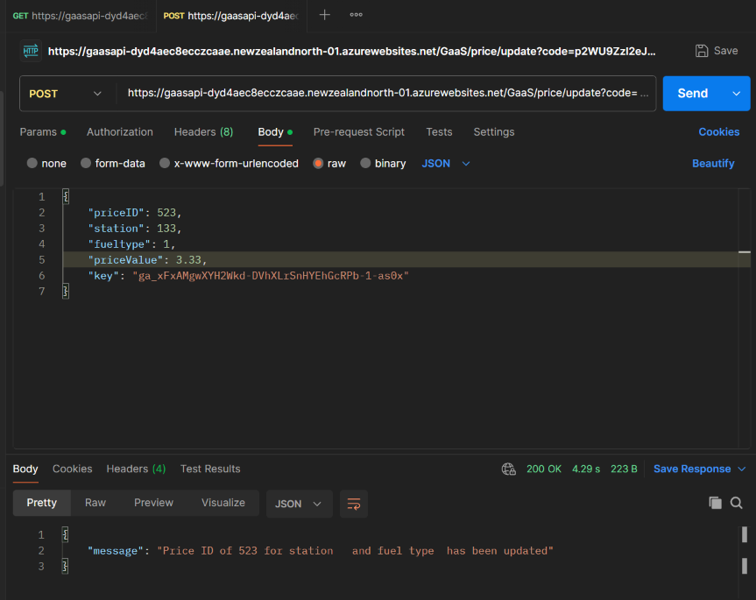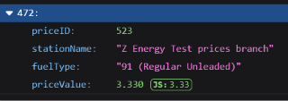 | Pass
TC10 | POST | DELETE a station which contains a fuel type and price.  URL:  https://gaasapi-dyd4aec8ecczcaae.newzealandnorth-01.azurewebsites.net/GaaS/station/delete?code=p2WU9ZzI2eJ8EvU9CN_WnmzXNL--0vtILxnWDv_2bLGTAzFu855Dbg== | The station with an Id of 133 is deleted, wiping records in both dbo.Station and dbo.Price. | 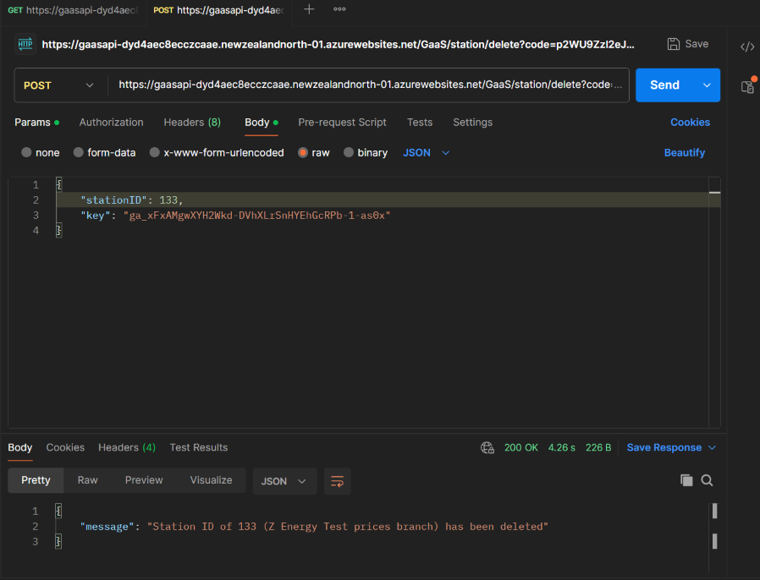  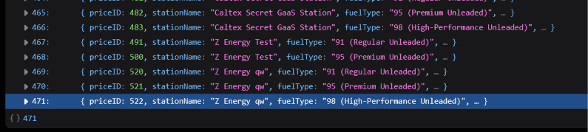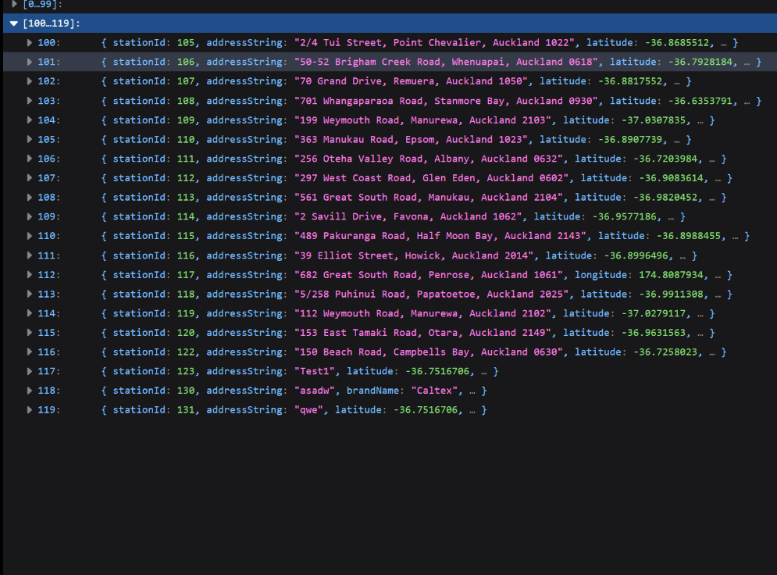 | Pass | To delete price records safely when deleting the station, the following condition is utilised.  if(station.Prices != null && station.Prices.Any()){ _dbContext.Prices.RemoveRange(station.Prices);}
TC11 | GET all nearby stations that are within a specific kilometre radius from a specific coordinate.  URL: https://geolocatoin-eyf7bqfefgfff8a2.eastasia-01.azurewebsites.net/api/location/query?longitude=174.871097&Latitude=-36.960539&radiuskm=5&key=ga_xFxAMgwXYH2Wkd-DVhXLrSnHYEhGcRPb-1-as0x | From a 5km radius from the coordinate (174.871097, -36.960539), receive a JSON file containing a list of 20 stations with the following parameters:  “stationID”  “brand”  “branch”  “addressString”  “longitude”  “latitude” | 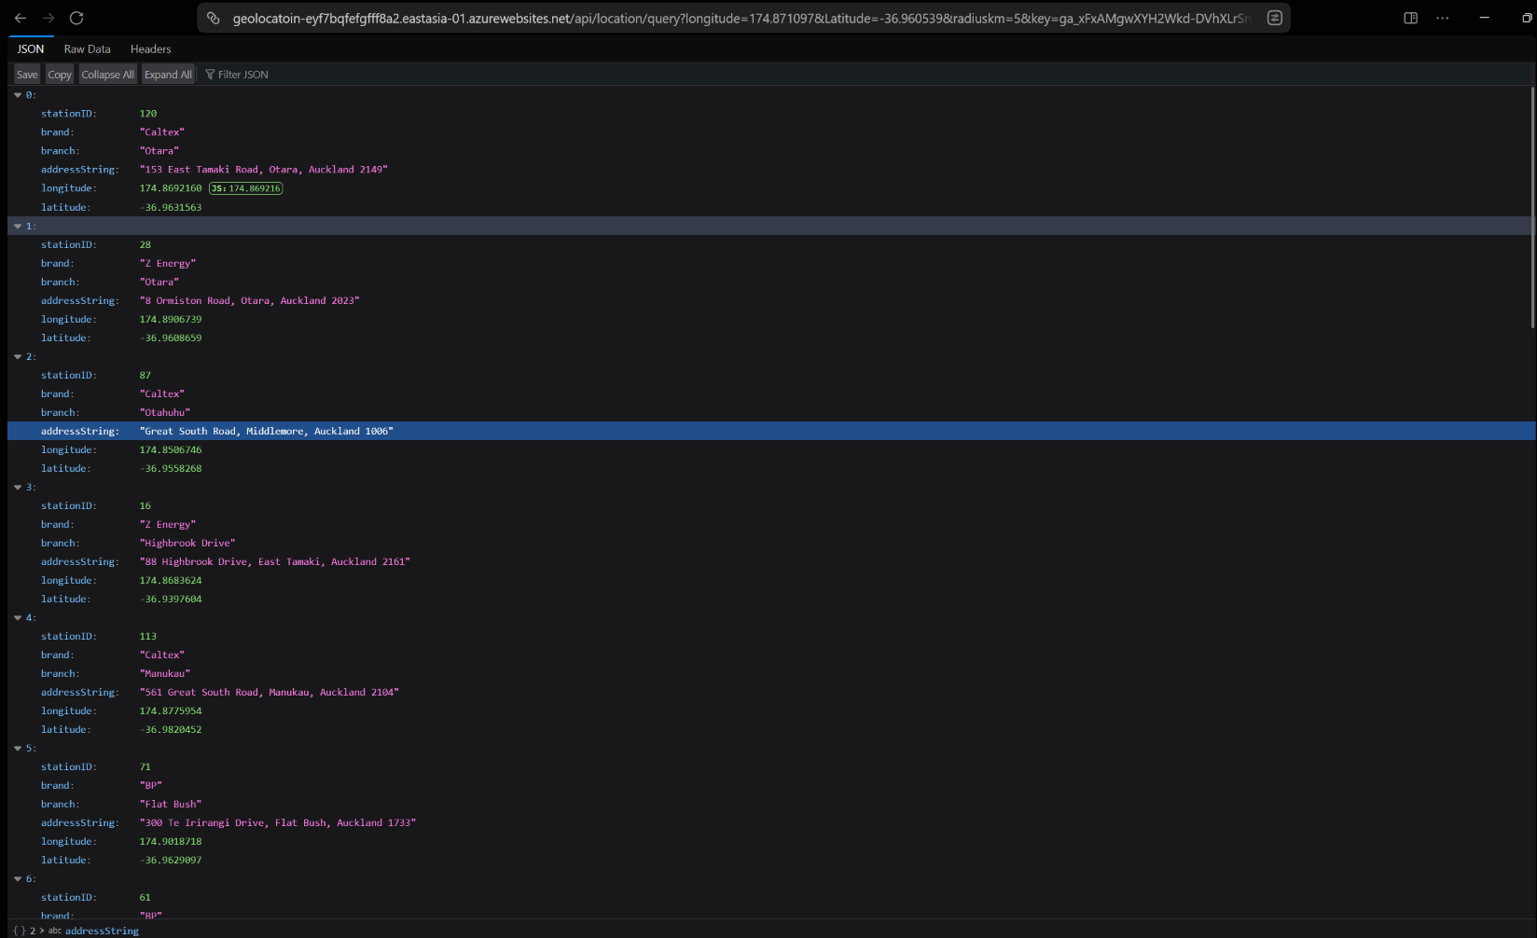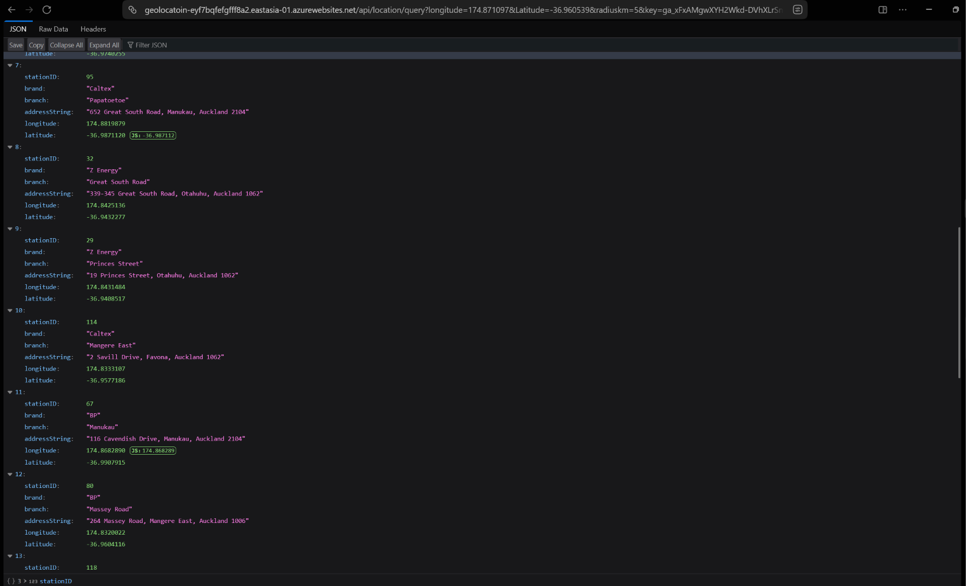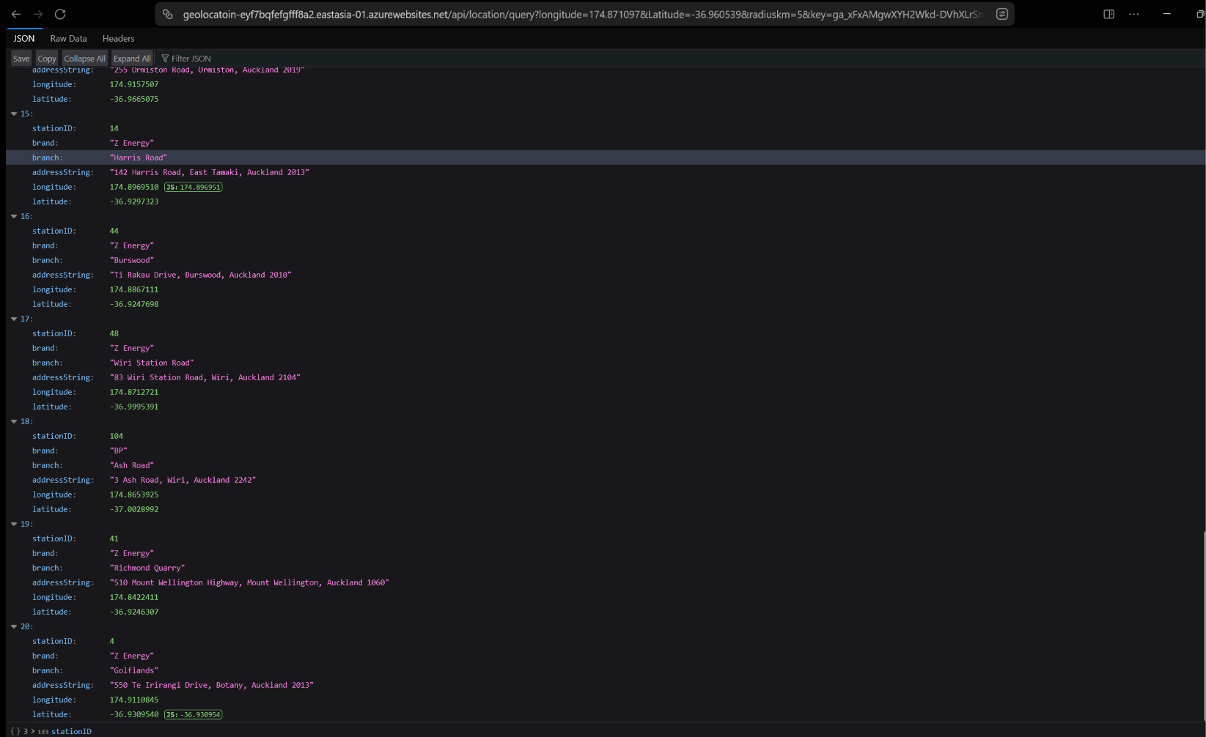 | Pass
TC12 | POST | Attempt to CREATE a station with no admin key or with a user key.  URL: https://gaasapi-dyd4aec8ecczcaae.newzealandnorth-01.azurewebsites.net/GaaS/station/create?code=p2WU9ZzI2eJ8EvU9CN_WnmzXNL--0vtILxnWDv_2bLGTAzFu855Dbg== | The attempt is blocked since an invalid api key is provided. | 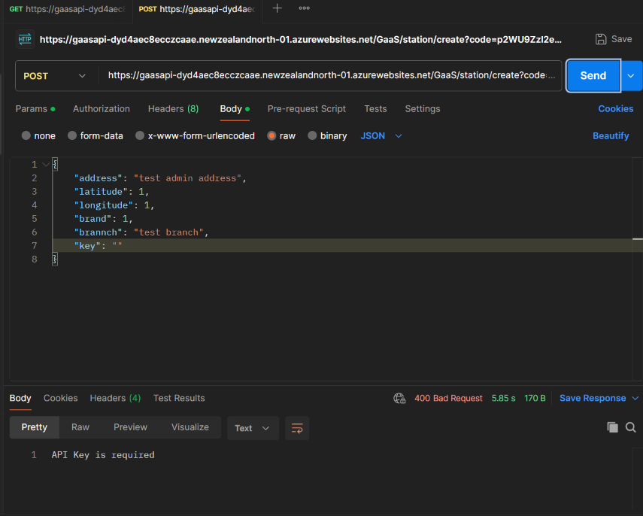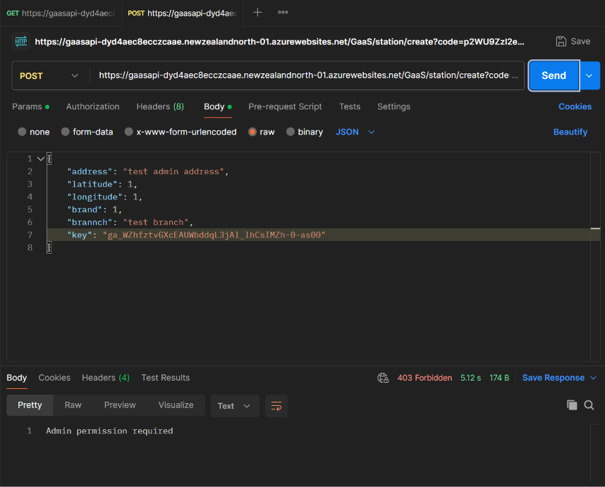 | Pass | The attempt to create a station is successfully blocked.
TC13 | POST | Attempt to UPDATE an existing station record with no key or with a user key.  URL: https://gaasapi-dyd4aec8ecczcaae.newzealandnorth-01.azurewebsites.net/GaaS/station/update?code=p2WU9ZzI2eJ8EvU9CN_WnmzXNL--0vtILxnWDv_2bLGTAzFu855Dbg== | The attempt is blocked since an invalid api key is provided. | 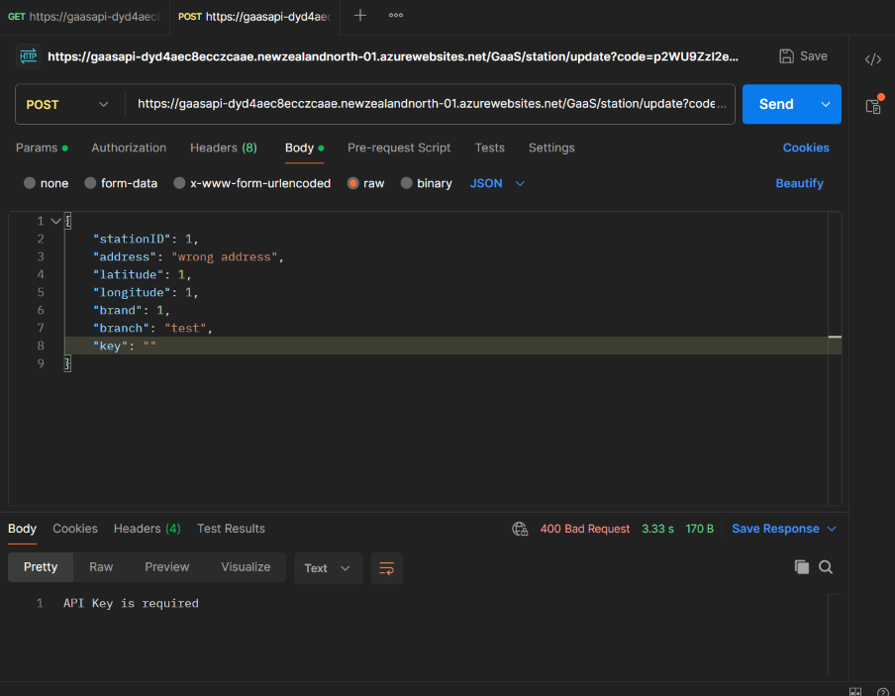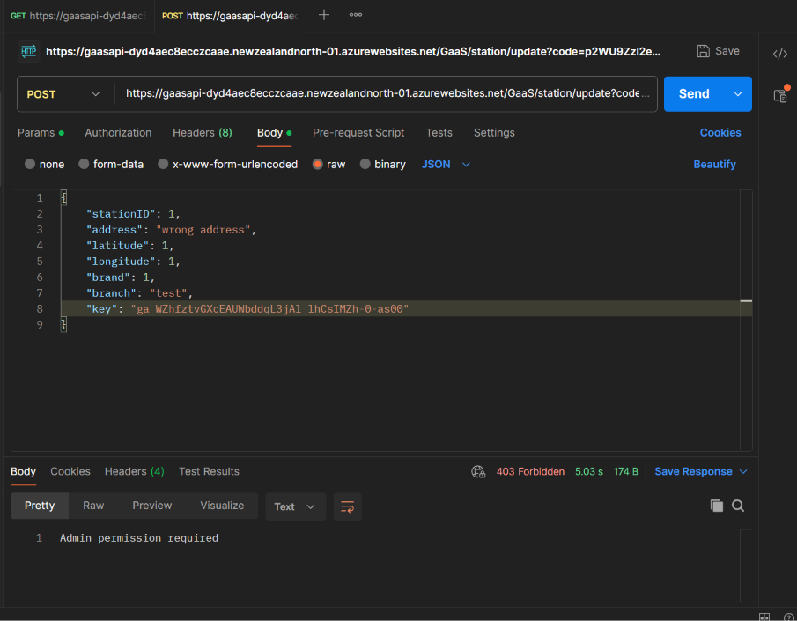 | Pass | The attempt to update a station’s details is successfully blocked.
TC14 | POST | Attempt to DELETE an existing station record with no key or with a user key.  URL:  https://gaasapi-dyd4aec8ecczcaae.newzealandnorth-01.azurewebsites.net/GaaS/station/delete?code=p2WU9ZzI2eJ8EvU9CN_WnmzXNL--0vtILxnWDv_2bLGTAzFu855Dbg== | The attempt is blocked since an invalid api key is provided. | 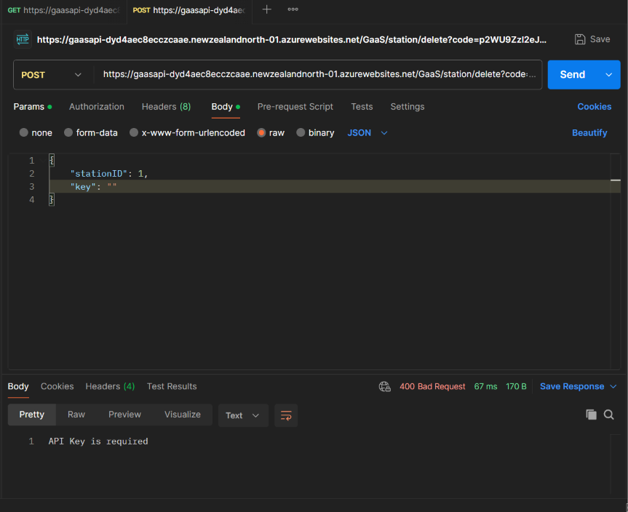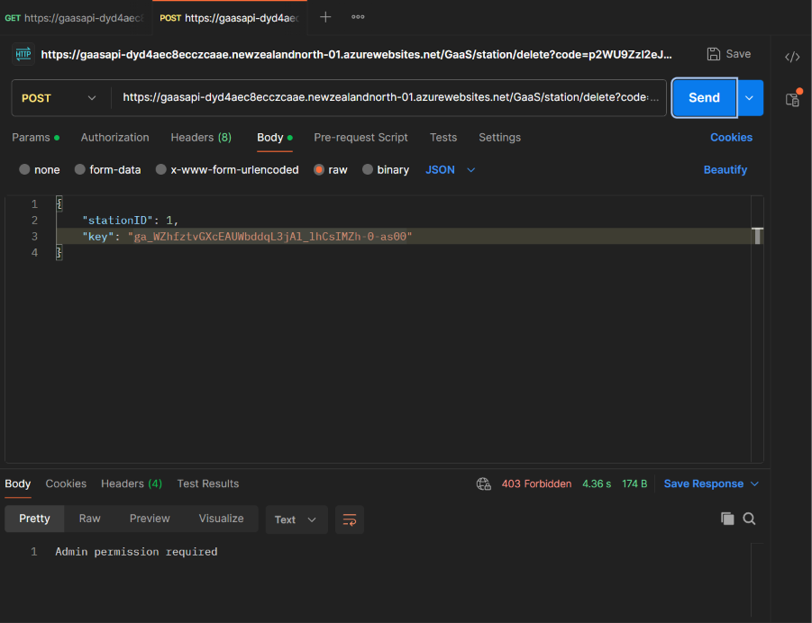 | Pass | The attempt to delete a station is successfully blocked.
TC15 | POST | Attempt to assign a fuel type and price to a specific station with no key or with a user key.  URL: https://gaasapi-dyd4aec8ecczcaae.newzealandnorth-01.azurewebsites.net/GaaS/price/create?code=p2WU9ZzI2eJ8EvU9CN_WnmzXNL--0vtILxnWDv_2bLGTAzFu855Dbg== | The attempt is blocked since an invalid api key is provided. | 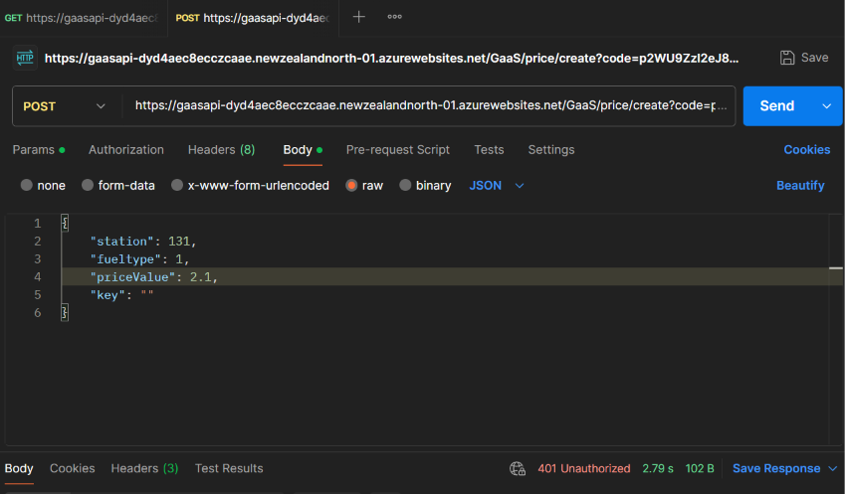  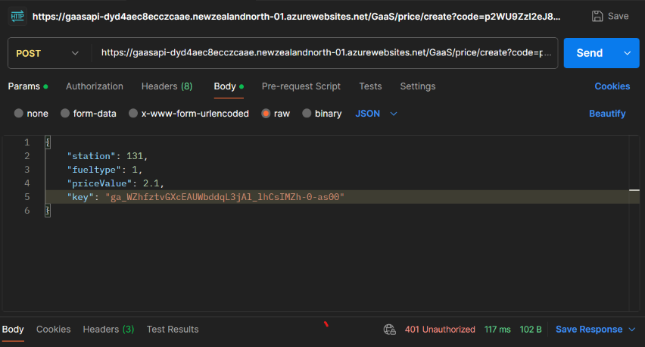 | Pass | The attempt to assign a price to a fuel type in an existing station is successfully blocked.
TC16 | POST | Attempt to UPDATE the price of an existing record with no key or with a user key.  URL: https://gaasapi-dyd4aec8ecczcaae.newzealandnorth-01.azurewebsites.net/GaaS/price/update?code=p2WU9ZzI2eJ8EvU9CN_WnmzXNL--0vtILxnWDv_2bLGTAzFu855Dbg== | The attempt is blocked since an invalid api key is provided. | 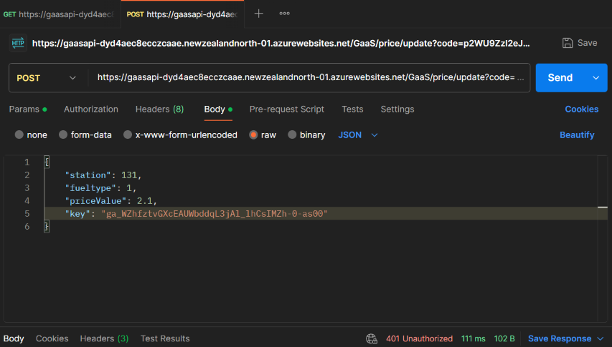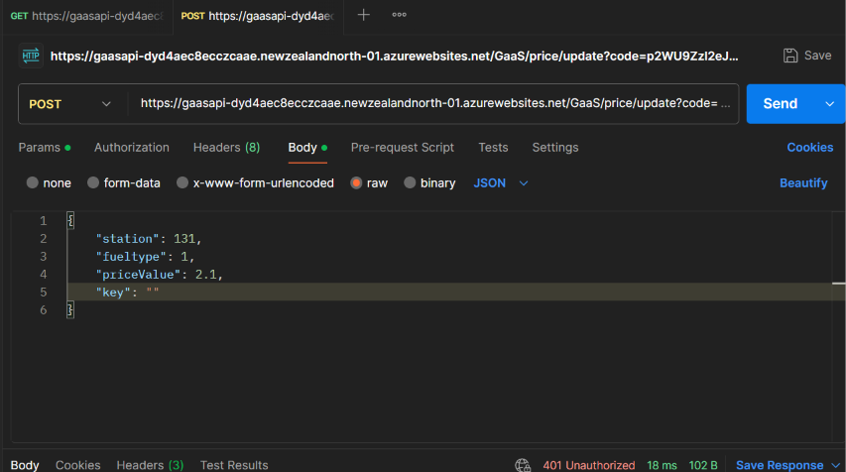 | Pass | The attempt to update the price to a fuel type in an existing station is successfully blocked.
Fig 15. Testing logs table

8.0 Team Contribution Report

8.1 Group Diary
Date | Start Time | End Time | Hours Worked | Category | Notes
22/09 | 15:00 | 17:55 | 2hr 55min | Planning | Created ERD and wireframe
28/09 | 12:30 | 15:10 | 2hr 20min | Planning | Created Kanban checklist, prepared documentation, Github repository and SOA diagram
29/09 | 13:00 | 15:30 | 2hr 30min | Planning | Created UML and System Architecture Diagram
7/11 | 21:30 | 1:30 | 4hr | Meeting | Reviewed the radius calculations, updated MVC website diagram and documented API design
10/11 | 15:00 | 16:00 | 1hr | Debugging | Debugging the station CRUD
10/11 | 21:00 | 3:30 | 6hr | Configuration and deployment | Configuring Azure publishing
Total Hours |  |  | 16hr 15min
Fig 16. Group diary table

8.2 Lois Dara Sanglap Diary
Date | Start Time | End Time | Hours Worked | Category | Notes
1/10 | 23:30 | 1:30 | 2hr | Planning | Created mood board and drafted wireframe
3/10 | 16:30 | 19:30 | 3hr | Planning | Completed the wireframing
4/10 | 9:30 | 14:00 | 4hr 30min | Designing | Initialised the prototype
5/10 | 13:30 | 16:30 | 3hr | Designing | Polished the prototype
8/10 | 15:30 | 19:00 | 3hr 30min | Designing | Completed the prototype
26/10 | 18:30 | 20:00 | 1hr 30min | Documentation | Wrote the system overview
2/11 | 8:30 | 11:40 | 3hr 10min | Documentation | Refined the system overview and inserted the diagrams
3/11 | 18:00 | 21:00 | 3hr | Development | Developed the Auckland POI, privacy policy and contact us page
6/11 | 12:15 | 17:15 | 5hr | Documentation and development | Created SOA diagram, wrote section 3.0 and explanation for each service  Created the about page
7/11 | 22:00 | 1:30 | 3hr | Documentation and planning | Updated MVC diagram and wrote API design and technology stacks
8/11 | 13:00 | 16:00 | 3hr | Documentation | Wrote GasS MVC website and functions in section 4.0-4.5
9/11 | 20:00 | 23:00 | 3hr | Documentation | Refined, fix grammars, finished section 3.0-4.0 and added group/individual diaries
10/11 | 20:00 | 23:00 | 3hr | Documentation and deployment | Added introduction, MVC definition and configurating Azure publishing
Total Hours |  |  | 40hr 40min
Fig 17. Dara diary table

8.3 Justin Grumal Diary
Date | Start Time | End Time | Hours Worked | Category | Notes
06/10 | 10:11 | 10:13 | 2m | Configuration | Created the GitHub repository, GaaS_Station.
06/10 | 10:13 | 13:41 | 3h 28m | Development | Initialised the MVC and started implementing the search box index.cshtml (Home).
07/10 | 13:01 | 18:05 | 5h 4m | Development | Improved responsiveness of index.cshtml (Home) and fixed styling issues.
08/10 | 08:29 | 11:10 | 2h 41m | Development | Implemented libre maps and integrated it with OpenFreeMap for index.cshtml (Gaas).
08/10 | 11:10 | 13:49 | 2h 39m | Development | Implemented Bootstrap offcanvas menu within Gaas’s index, a container for all search results.
09/10 | 13:49 | 14:50 | 1h 1m | Development | Added and styled the zoom buttons for libre maps.
09/10 | 14:50 | 15:02 | 12m | Development | Restricted map boundaries to Auckland only.
24/10 | 09:31 | 11:30 | 1h 59m | Development | Scaffolded identities and implemented login capabilities.
25/10 | 10:01 | 15:17 | 5h 16m | Development | Styled Register.cshtml, Login.cshtml, .ForgotPassword.cshtml, .ResendEmailConfirmation.cshtml, and .ConfirmEmail.cshtml
25/10 | 15:17 | 22:36 | 7h 19m | Development | Created an admin controller and its respective view. Developed account CRUD functionalities.
02/11 | 14:03 | 19:12 | 5h 9m | Development | Styled admin views.
03/11 | 13:41 | 15:55 | 2h 14m | Development | Added another external api, OpenWeatherMap.
05/11 | 19:32 | 20:43 | 1h 11m | Development | Restyled OpenWeatherMap’s display.
06/11 | 08:42 | 12:57 | 4h 15m | Development | Review and improve the admin controller.
07/11 | 13:32 | 18:53 | 5h 21m | Development | Merged with Dustin’s branch, integrating GaaS API and GeoLocation.
08/11 | 08:32 | 22:43 | 14h 11m | Development | Review how to make station CRUD logic.
10/11 | 07:22 | 23:59 | 16h 37m | Development | Implemented CRUD logic to the admin controller and designed their respective views.
11/11 | 09:01 | 09:24 | 23m | Configuration and deployment | Finalise azure configuration by connecting the core web api, GeoLocation, to the MVC, GaaS_Staion.
11/11 | 18:39 | 21:06 | 2h 27m | Documentation | Worked on Section 7.0, Test Logs. Conducted testing on azure function’s (GaaS-API) Station and Price CRUD. Furthermore, I tested core web api’s (GeoLocation) to verify it displays stations within a certain radius.
11/11 | 21:16 | 21:40 | 24m | Deployment | Amended the GitHub repository to include the azure function and core web api (Was not located in the same file directory).
Total Hours |  |  | 81 hours and 53 minutes
Fig 18. Justin diary table

8.4 Dustin Dwayne Diaz Diary
Date | Start Time | End Time | Hours Worked | Category | Notes
29/09 | 13:00 | 16:00 | 3hr | Development | Worked on website design and system diagrams.
08/10 | 13:00 | 20:00 | 5hr | Development | Refined database design, relationships, and SQL queries.
10/10 | 2:00 | 4:00 | 2hr | Development | Set up the Azure Functions API and configured database connectivity.
16/10 | 13:00 | 16:00 | 2hr 40min | Development | Set up API endpoints and database queries for retrieving station information.
23/10 | 12:00 | 15:00 | 2hr 30min | Development | Developed endpoints for retrieving fuel prices and station details.
30/10 | 13:00 | 16:00 | 2hr 45min | Development | Implemented API-key authentication, permission checks, and request validation.
02/11 | 13:30 | 16:30 | 2hr 30min | Development | Developed nearby station search using geographical coordinates and search radius.
05/11 | 11:00 | 14:00 | 2hr 40min | Development | Implemented the Haversine formula and refined distance-based station filtering.
09/11 | 13:00 | 16:00 | 2hr 30min | Documentation | Worked on backend documentation, API descriptions, and system architecture diagrams.
Total Hours |  |  | 27hr 55 min
Fig 19. Dustin diary table

9.0 Bibliography
Anandamurugan, S., & Priyaa, T. (2015). Service-oriented architecture.
Anderson, R. (n.d.). ASP.NET MVC overview. Microsoft Learn. https://learn.microsoft.com/en-us/aspnet/mvc/overview/older-versions-1/overview/asp-net-mvc-overview
Edmunds, S. (2026, April 30). Is 2026 going to be another expensive year? RNZ. https://www.rnz.co.nz/news/business/593786/is-2026-going-to-be-another-expensive-year
Lindemulder, G., & Kosinski, M. (n.d.). What is role-based access control (RBAC)? IBM. https://www.ibm.com/think/topics/rbac
Mulesoft. (n.d.). Services in SOA. Mulesoft.com. https://www.mulesoft.com/integration/service-oriented-architecture
Veness, C. (n.d.). Calculate distance and bearing between two latitude/longitude points using haversine formula in JavaScript. Movable Type Scripts. https://www.movable-type.co.uk/scripts/latlong.html

